How to Create a Weebly
Go to student.weebly.com
Log In – Username/email:
Password: abc123
1st time creating site:
- Click ADD SITE
- Click SITE
- Scroll through the themes and choose one – you can always change these later – Click CHOOSE
- Use a subdomain of weebly – type in your topic name … .weebly.com
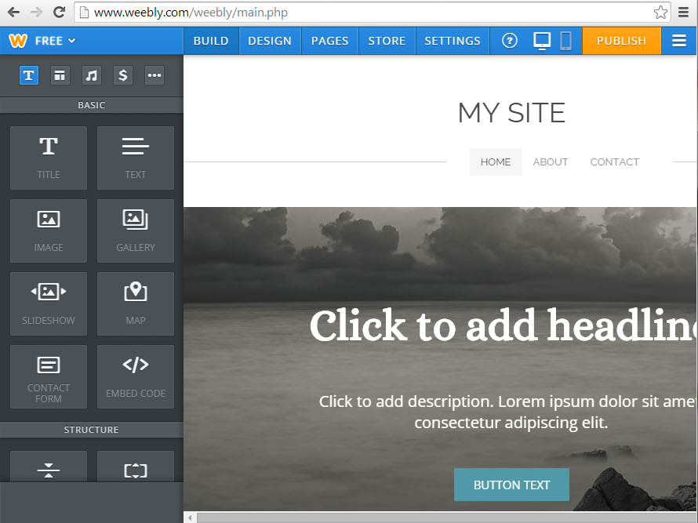
- Click CONTINUE
Drag and drop boxes on the left, the “elements” to the open areas on the screen. The element will go where the blue line appears on the page.
Click and follow the directions in each box.
To change the title and other headlines – click and type your own information.
Edit background images by clicking EDIT on the image.
DESIGN TAB – changes the themes and colors of the site – not often used
PAGES TAB – add pages to your site, organize pages on your site, and change the title and format of pages.
Click on the different pages to add “elements” to all of the pages.
All changes are automatically saved. Clicks PUBLISH in order to make the site visible to all on the internet.
Add IMAGE – To add an image, drag the element “image” to the open work space. Upload a picture saved on the computer, search for a picture through the site, or copy and paste an image url (must be formatted).
To add a video from YOUTUBE – use the “embed code” element – copy and paste the embed code
BUTTONS – buttons can be clicked by page visitors to link them to another website, to open a document, link to another page on your site, or to send an email
Returning Site Edit:
- Log in
- Click EDIT next to site name
- Make any changes
- Click PUBLISH at the end

