Names: ---------------------------------------------------------------------------------------------------------------
Circle the type of animal you will create.
Mammal  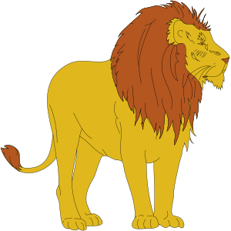 | Fish  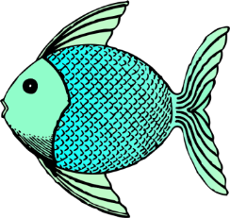 | Bird  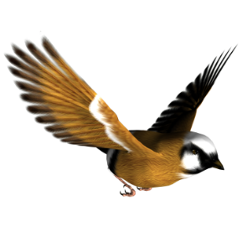 | Reptile  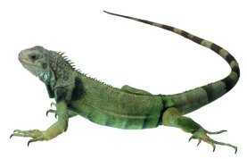 |  | Amphibian  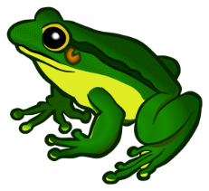
List three characteristics of this type of animal. | How do they breathe or where do they live?
 | What is their skin like?
 | What are the babies like?
 | Other:
Why will your new animal need to camouflage in the classroom? | Is it a predator? Or prey?
Create a plan for your new animal on the back of this page.
Think about where it will hide and what it will look like.
Will it have a special color or texture?

Take a look around your classroom.
Draw your new mammal, fish, reptile, amphibian, or bird in this habitat.
Name of your new classroom animal:
Tomorrow you will create this animal out of construction paper and share it with the class.
Bonus:
If you created a predator, what is its prey?
If you created prey, what is its predator?
Draw a picture of the animal in its classroom habitat.
Name of the new animal:

This is a
It’s body is covered with
It is a .It uses camouflage to hide from

