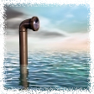
Periscopes of the Deep
Most submarines have a periscope in order to allow the crew to see above the surface of the water. The periscope can usually be extended to a length of up to 60 feet, and can be swiveled to give the operator a 360 degree view of the ocean surface. The lowest depth at which a submarine can use a periscope is called theperiscope depth.

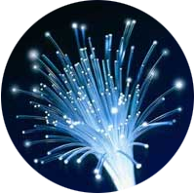
Fiber Optic Cables
Optical fibers work in a similar way as your periscope. The fibers are thin strands of glass that are surrounded by a reflective glass coating that acts as a mirror. Signals of light are sent through one end bounce around inside the strand until they reach the other end. When light reflects off of a glass surface instead of passing through it, it is called total internal reflection. Fiber optic cables are rapidly replacing copper wires in many areas of communication.

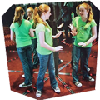
World's largest mirror maze
Mirror mazes are a frequent sight at amusement parks and county fairs. Their floor-to-ceiling mirrors confuse guests by producing reflections that represent dozens upon dozens of points of view. Many guests give up on their eyes altogether and keep their hands forward to feel their way to the exit. The world’s largest mirror maze is located in Gatlinburg, Tennessee.

