Newton and the Seven Colors
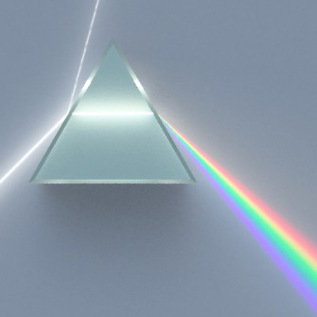
Sir Isaac Newton discovered that white light is composed of many colors in the late 1600's. He demonstrated that a beam of white light passing through a prism separated into at least seven distinguishable colors − the colors that we see in a rainbow. He was also the first to suggest the color wheel experiment described above.
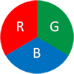
Millions from Three Colors
Our eyes and digital cameras sense color by determining the amount of red, green, and blue contained in images. Computers and TV monitors display color based on the same principle, by mixing different amounts of red (R), green (G), and blue (B) light.

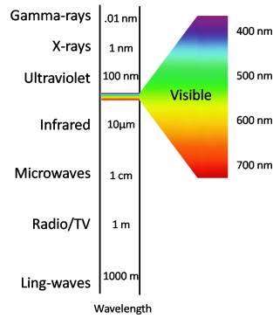
Electromagnetic Spectrum
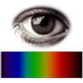
Our eyes can see millions of shades of color between violet and red. This entire range is called visible light. But visible light is only a tiny fraction of all the light that exists. For example, invisible light rays include X-rays, microwaves and radio waves. Together, visible and invisible light are called electromagnetic waves, and the entire range is called electromagnetic spectrum.

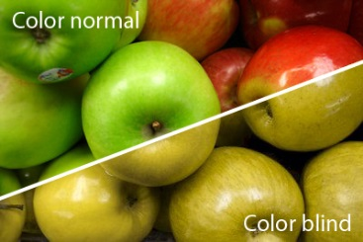
Red? Green? yellow?
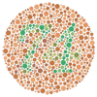
Roughly 1 in 20 people have some sort of color deficiency, called color blindness, that makes them unable to distinguish between some of the colors that other people can see. For example, a person having red/green color blindness finds it hard to tell red and green apples apart: both would appear yellow. A person can also be completely color blind, perceiving only shades of gray.
Can you see the number imprinted on the selected tab above? If so, you are not 'red-green' color blind [4].

